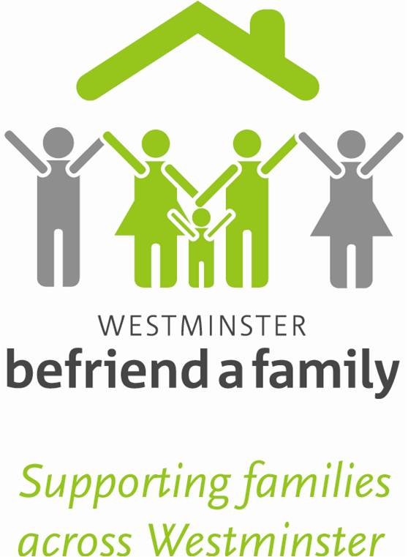
Donation Form
Details of Donor:
Title………… Forename (s) ………………………………..
Surname……………………………………………
Address……………………………………………………………………………..
………………………………………………………………………………………….
………………………………………………………………………………………….
Post code………………………………………….

Option 1 – to pay by Direct Debit (this helps reduce our administration costs)
Standing Order, start date ……………………………………………
Bank Name……………………………………………
Bank Branch Address ………………………………………………………………………………………………………………………
Post Code ……………………………………………
ACCOUNT TO BE DEBITED
SORT CODE ……….….-………….-………….…. ACCOUNT NUMBER ………………………………………
BENEFICIARY DETAILS
Westminster Befriend a Family
Bank, Natwest, Westminster Branch, PO Box 3038, 57 Victoria Street, London, SW1H 0HN
Sort Code; 56-00-33
Account Name; 11369876
Option 2 – to make a cash gift
Please accept my gift of: £5 £10 £25
My preferred amount £
I enclose a: Cheque Postal Order CAF voucher made payable to Westminster Befriend a Family
Signature Date

