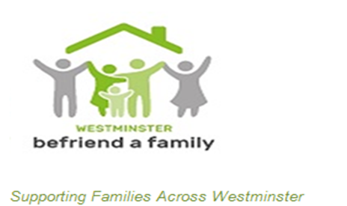
Westminster Befriend a Family
18 Buckingham Palace Road
London
SW1W 0QP
Tel: 020 7828 2765
Fax: 020 7828 2780
Email: Loris@befriendafamily.co.uk

Westminster Befriend a Family
SELF ASSESSMENT QUESTIONS
Family Befriending Referral Form

Family Information

Name:
Address:

Phone:
How would you describe your ethnicity?

What languages do you speak at home?

Who else lives in the family home?:

Name | Relationship | Date of Birth | Age
Do you have any other people working with you, for example family support worker or social worker, or anyone else?
Name:  Profession:  Telephone:  Type of Support provided: | Name:  Profession:  Address:  Telephone:  Support provided:

Does anyone in the family have any of the following issues? If yes please circle and state who.
Physical disability
Long term health condition
Learning difficulty
Mental health condition
Behaviour difficulties
Domestic Violence

What help would you like from a Befriender? Please circle
Parenting

- Managing children’s behaviour

- Supporting children’s learning

- Supporting children’s health/ wellbeing

- Coping with conflicts at home

- Other

Personal
- Getting to know more people in the community

- Support in finding next steps in education or training

- Support towards finding work

- Supporting your health or wellbeing

- Other

What do you hope to achieve by having a befriender?

WBAF befrienders work with families for six months.

By signing this and agreeing to this referral you are giving consent for us to hold your personal information in our electronic records.

Your Signature:

Todays date:

We are looking forward to working with you!

If you have any queries please call

Loris Konaizeh ,

WBAF Service Co-ordinator :

Tel: 020 7822 82765

Or email: Loris@befriendafamily.co.uk

